**How to Install Selenium IDE on an user’s PC**

Contents

Pre-requisites: 2

How to install Selenium IDE in Firefox browser? : 2

How anyone can ensure if Selenium IDE is installed in the Firefox browser? : 5

How to create/ Run first IDE script? : 6

# Pre-requisites:

* Firefox browser should be installed
* Internet Connection

# How to install Selenium IDE in Firefox browser? :

* Launch the Firefox
* Access URL ‘http://seleniumhq.org/’

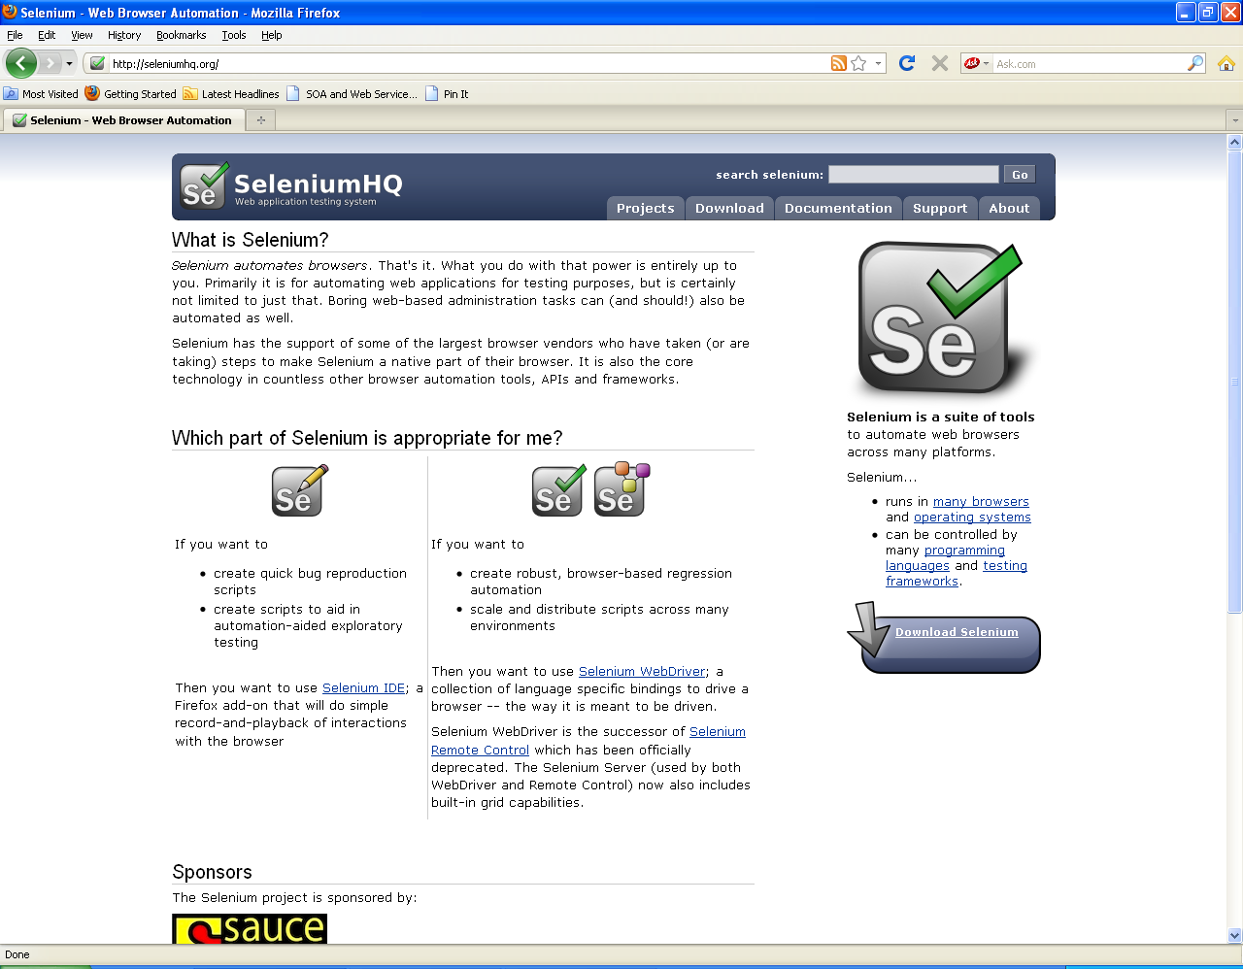

* Click Download tab to move on download page

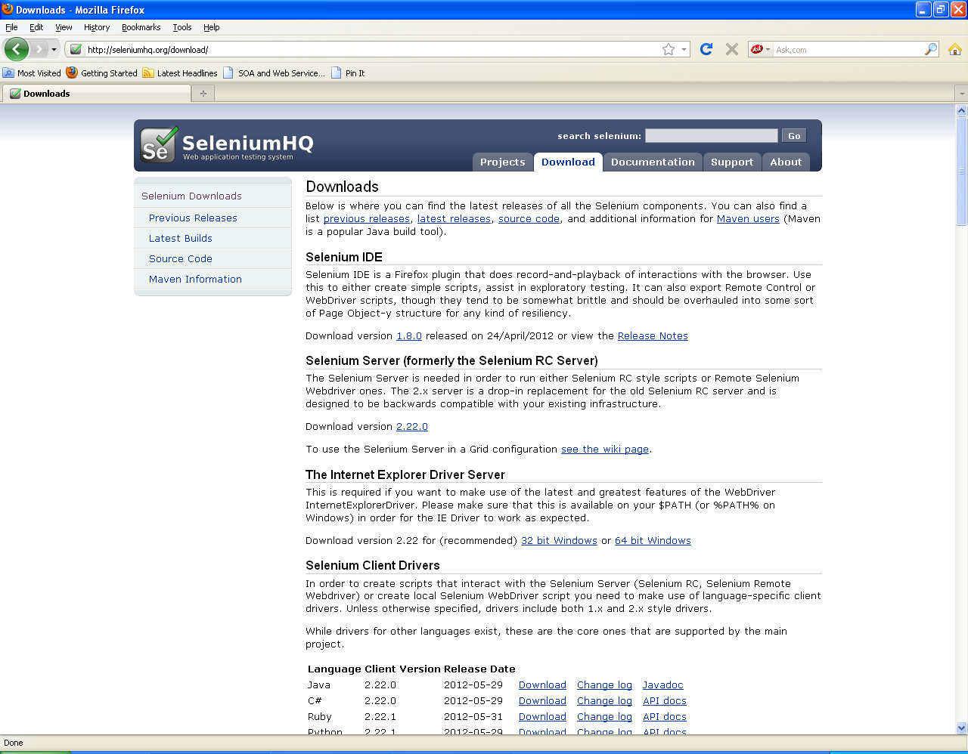

* Under the Selenium IDE heading, click the link that is for the latest release
* If Firefox prevents the site then make it Allow
* Software Installation window popup appears

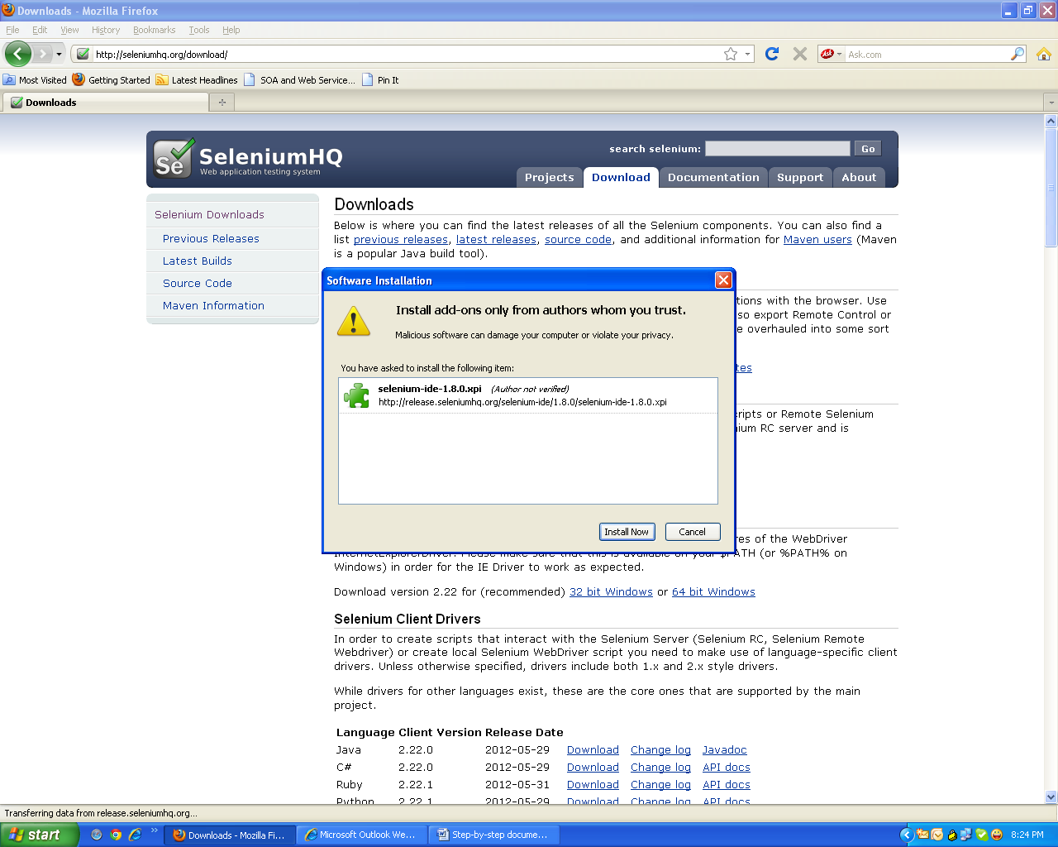

* Wait for the time unless Install button gets enable, as you get Install button enable, click it
* Wait until installation is in process

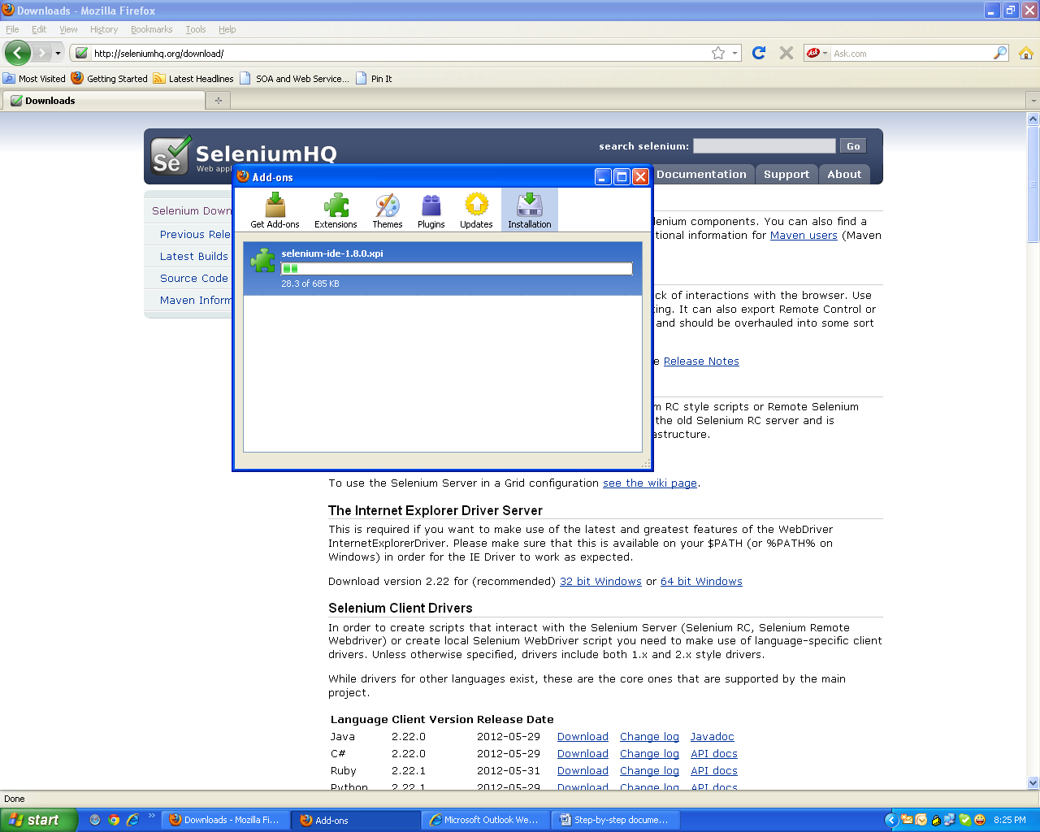

* Once installation is completed then it will prompt for restarting browser
* Restart the Firefox browser

# How anyone can ensure if Selenium IDE is installed in the Firefox browser? :

* Launch the Firefox
* Go to Tools menu and if Selenium IDE menu option is available then its installed

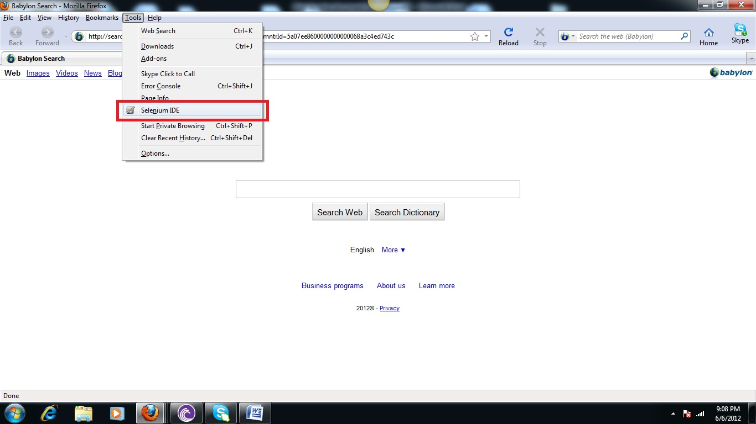

# How to create/ Run first IDE script? :

* Launch the Firefox
* Go to Tools -> Selenium IDE menu option

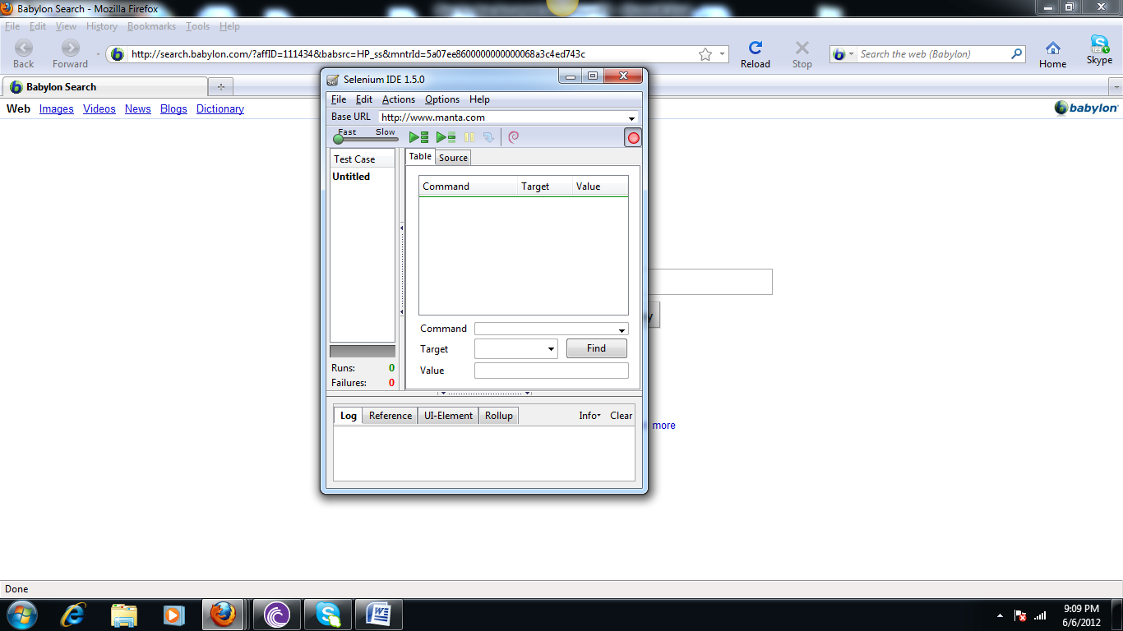

* When red circle icon is clicked then record a script
* To run an existing scripts:

1. Click File Menu
2. Click Open
3. Browse the path where .html script is located
4. Open it
5. Click “Play Current Test case” icon button
6. Your script gets run
7. If all steps are green after run then it means it pass or some steps might be failed